The Riemann Zeta function applied on the glassy systems and neural networks
V.L.Cartas
The glassy systems and the neural networks have a simple model of study, the model of a set of N non interacting harmonic oscillators with energy. In this paper the author tries to describe the complex systems in order to find the energy involved. The mathematical method is described on large.

1.The Crisanti –Ritort model; the energy of the complex glassy systems

Glass is a material which is in a metastable state. Its free energy is higher than that of a crystal. This is obtained by stretching the liquid line from the space of the phases above the melting temperature. The state corresponding to glass is experimentally obtained through a rapid cooling of the liquid. Glass has properties which makes it similar both to liquid and solid materials, without being either of them. For example, what makes it resemble the liquid materials is the random placement of the atoms, and what makes it resemble the solid materials is the reduced mobility of the atoms. Glass has various and remarkable proprieties. It presents anomalies of the behavior of its viscosity (its viscosity has a heteroclite behavior.) This grows very fast within a short domain of the temperature. The viscosity of glass may change for tens of times due to a variation of the melting temperature with only a few percents. There is a law (formula) which describes this variation accurately enough, and that is Vogel exponential law. Supercooled glass has a function of relaxation which presents two distinctive areas corresponding to the different processes that may appear during this type of process. Another interesting phenomenon characterizing glass is the phenomenon of aging. The viscosity grows with the time t according to a linear law, the growth being very slow. All these properties shows that the state of the glass is a particular state that must be considerate distinctive from the other states of the matter.

In order to simplify the study of such a complex system as the glass, many models have been suggested. In [1],[2] A. Crisanti and F. Ritort propose a model which is defined by a set of N non-interacting harmonic oscillators with energy:
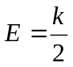 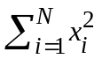 (1)
with 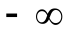<x<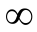, where k is a coupling constant. An effective interaction between oscillators is introduced through a parallel Monte Carlo dynamics characterized by small jumps
x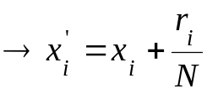 ; 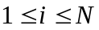, (2)
where the variables r_{i} are extracted from a Gaussian distribution. At each Monte Carlo step all oscillators are updated following the previous rule. The smallness of the jumps in the variables x_{i} is required in order to give a finite change in the energy so that the head N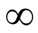 could also be taken into consideration. This model must be discussed strictly within its domain of applicability. A. Crisanti and F. Ritort use it in order to study the relaxation after quenching to zero temperature. In this paper the Crisanti-Ritort model is used in order to express the energy of the complex glass system. For this we will use (1) considered after a finite number of jumps according to the formula (2). The number of oscillators is considered to be infinite. For the accuracy of the calculation, the Riemann zeta function is introduced in the expression of the energy:
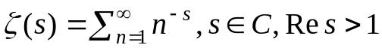 (3)
Now the expression (1) becomes:
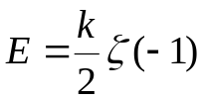 (4)
The series (1) will be divergent and this formula implies an analytical continuation through the zeta function. That is why such regularization can be termed as a particular case of analytical continuation procedure. The Riemann zeta function 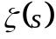 is given by the series expression (3) in the region of the complex s-plane where Re s>1. In the rest of the complex plane is not given by the series (1) (which is divergent). There is one and only one function that is meromorphic and is similar to our initial series within the domain of convergence. We extend its definition to the rest of the plan (except for the point s=1 on the real axis). The generalized zeta function had already been used in [3] and [4] in a manner that we nowadays call regularization of one-loop groups [5],[6] and which essentially consist in attaching zeta functions not to path integrals, but to Feynman diagrams themselves. A modern formulation of this method has been developed in [7],[8]. In this paper the calculation of zeta function that is used in the expression of the energy is made starting from the relation:
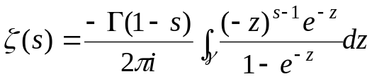 (5)
which is valid for the entire complex plane; the system is represented in the fig. 1.

In order to calculate the integral expression from the formula (5) we start from the Mac-Laurin development :
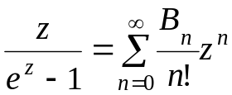 (6)
With the help of (6) we can write:

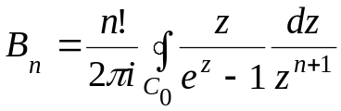 (7)
where B_{n} are the Bernoulli numbers and C₀ is a circle having the center in the origin and the radius smaller than 2 traversed in the direct way. The integrals (7) are solved for n2, deforming the contour C₀ as in fig. 2.
In the interior of the contour, supposing that R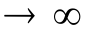, there are an infinity 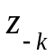purely imaginary simple poles of the function that appears in the integral (7) and which have the form 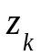=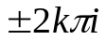, k. Due to the fact that the integrals on the Ox axis are reduced, and the integral on the circle of radius R goes to zero, for R results:
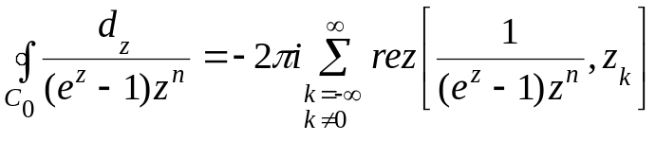 (8)

But:
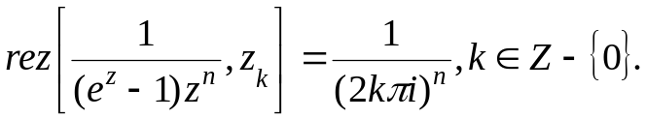

If n=2m+1, m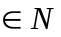, the residue in the points =2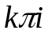 and =-2 reduce themselves and from (7) and (8) results B_{2m+1}=0, m; if n=2m, then the residues in the points z_{k} and z _{-k} are equal, and from (7) and (8) we obtain:
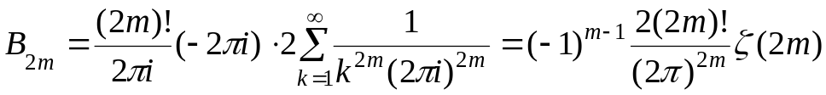 (9) Now we can consider in (5) that s= -1 and (5) becomes: 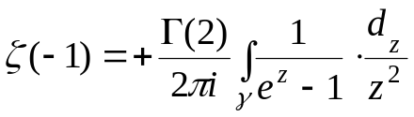 (10)
From (7):
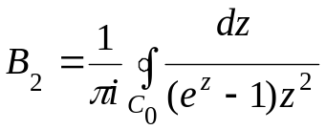 (11)

From (6) and (7) we obtain:
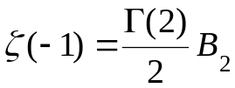 (12)

From (4), the expression of the energy becomes:
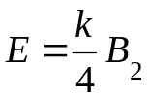 , (13)
or:
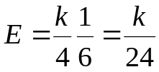 . (14)

In the conditions of the formula (14), the expression of the energy depends only on the coupling constant which characterizes the studied glass system.

2.The Neural Networks Through Zeta Functions

The parametrical estimation of the neural networks is carried out considering a statistical model [9]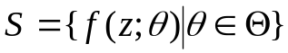 which is a family of probability density functions, where the space parameter is a domain in R^{d}. We suppose that f(z, 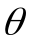)>0 for all z and , and that f(z, ) are C on for any z. the likelihood ratio and the Kullback-Leiber divergence are defined by:
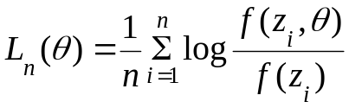 (15)
and
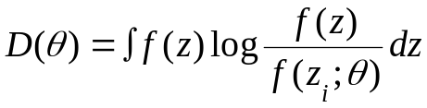 . (16)

Feed-forward neural networks like multilayer perceptions can be described within this framework. Let xR, s(t)= tanh(t) and =(a_{j},b,c,d)^{T}. The multilayer perceptron model with H hidden units is a family of functions defined by [10]
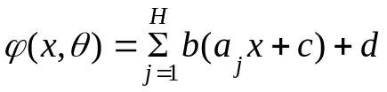 . (17)

This type of function is useful when studied in the form H; d=0
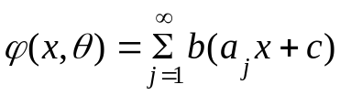 . (17’)

Using the Truncated Epstein zeta function:
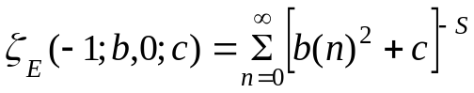 (18)

and making the substitution 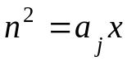 we can write:
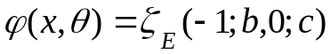 . (19)

For this type of function, we can write, together with Elizalde [10], the asymptotic series :
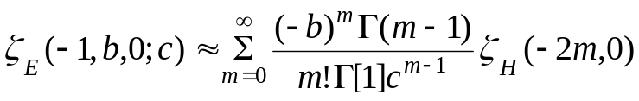 (20)

where _{H} is Hurwitz’s zeta function. Elizalde also presents in [10] the modality of the analytical continuation of the function. The expression (20) offers, anyway, though the zeta function, an expression of the function family that describe the multilayer perceptron model.

3.The topology of the glassy system and neural network models

In this paragraph, the application of the topological program is presented, for the study of the behavior of the dynamic systems introduced in [11],applied on the glassy systems and the neural networks discussed in the previous chapters. Starting by considering these systems as systems of free oscillators with the Hamiltonian
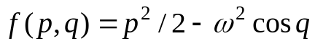 (21)
where 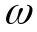 is a real parameter. The phase space is the cylinder 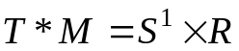, and the Hamiltonian vector field
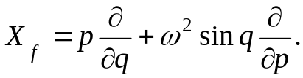 (22)
There are no other first integrals. There are two critical points to f: 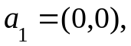 a minimum, and 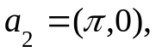 a saddle point. Since 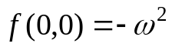 and 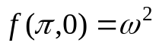, we see that 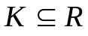 is the two-point set 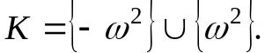. From Morse theory we deduce that the maps 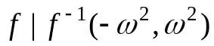 and 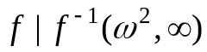 are differentiable fibers. The level structure of f, such as the orbits of the flow of 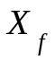, is summarized thus: for 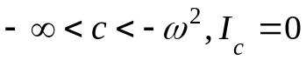; for 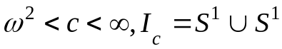, the disjoint union. There is a periodic current on each of the components. For 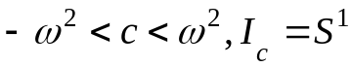
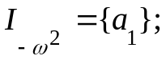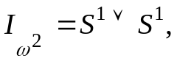
the union being joined at the point 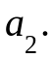 This is a bouquet of circles, an eight shaped curve. The level set 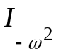 separates the empty class of orbits from the small oscillations. The level set 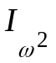 is also a separatrix; in its vicinity there are two types of motion: the small oscillations in 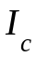 for 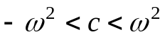, and the full turns of the pendulum ( with 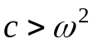). Obviously, the topological type of changes in the ‘hood of K.

4.Summary

This paper is meant to emphasize the utility of using the zeta function in the study of complex systems such as glassy systems and neural networks. In both types of systems, the calculus of their internal energy can be done only by using some study models. From the large variety of study models, the paper focuses on the Crisanti-Ritort model, which is used as a starting point for the calculus of energy. The calculus problems can be solved by using the zeta function, but only together with the the analytical continuation of the function that has been developed in the past few years, especially given to the scientific activity of Elizalde and others.

It is a pleasure for me to thank Emilio Elizalde for having encouraged me in my work .
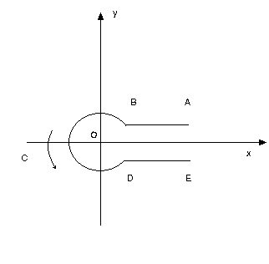
Fig.1

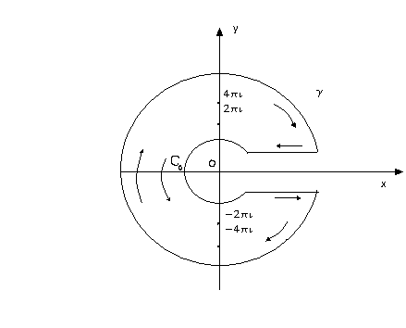
Fig. 2

References

- A.Crisanti,F.Ritort,A.I.P.,553,81(2000)
- F.Ritort,Phys.Rev.Lett.,75,1190(1995)
- E.Elizalde,J.Math.Phys.,35,3308(1994)
- E.Elizalde,J.Math.Phys.,31,170(1990)
- E.Elizalde,J.Phys.,30,2735(1997)
- E.Elizalde,L. Vanzo,S.Zerbini,Commun.Math.Phys.,194,613-630(1998)
- I.Brevik,H.B.Nielsen,Phys.Rev.,D41,1185(1990)
- B.F.Svaiter,N.F.Svaiter,Phys.Rev.D47,4581(1993)
- K.Fukumizu,A.I.P.,553,117(2000)
- E.Elizalde,J.Comp.App.Math.,118,125(2000)
- V.Cartas,An.Univ.Galati,222,79(2001)

