The effect of flow attenuation mechanisms on flooding and the fate of pollutants in urban drainage systems

This 4 year project is part of the STREAM-Engineering Doctorate Program and in collaboration with Hydro International Plc. The main project aim is to investigate the implementation of the Hydro-Brake® Flow Control into storm drainage networks and hence reduce flood risk and contribute towards pollution mitigation strategies.

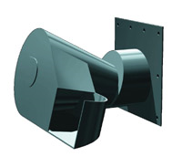

Type CH Hydro-Brake Flow Control (Hydro International Plc, 2012)

For further information, contact Dr Fayyaz Ali Memon [f.a.memon@ex.ac.uk](mailto:f.a.memon@ex.ac.uk)