‘CHECK DAM’ HELP FILE

NRWS helps you design a check dam by running a simulation that determines ideal reservoir storage capacities or percent reliability levels. It is ideal to construct a check dam where the basin is underlain with bedrock or unconsolidated formations with low permeability and the valleys are well defined and narrow. This reduces the construction costs, makes it easier to assess storage volumes, and helps to control seepage losses. Utilising the storage requirements from the check dam simulation involves further field work to develop the design specifications of the dam. As opposed to standard sizes of tanks used for capturing rainwater, a dam reservoir has complex geometry that requires an estimate of the elevation level needed to hold the desired volume of water.

There are three check dam simulation options to choose from. The first two simulation options are applied when the user has specific requirements for percent reliability as requested by the village, or the maximum storage capacity based on the spatial availability and economic conditions of the village. Otherwise, the user can choose to create a graph that compares the two variables in order to determine a balance that maximises their effectiveness. If the graphing option is used, the user must still run through one of the first two options in order to obtain the necessary output values for the sub-module.

To run the check dam simulation you must gather the appropriate information. If you require help developing any of the input variables for the simulation, click on the respective variable in the list below. To return to this menu, click on any of the arrows at the bottom left corners of the variable descriptions. Click here to view a diagram of the check dam system.

- REGION OF CHECK DAM LOCATION
- STORAGE CAPACITY OF THE TANK
- INITIAL STREAM DISCHARGE
- DAILY FLOW DATA
- RATIO OF RESERVOIR SURFACE AREA TO DEPTH
- PERCENT RELIABILITY
- VILLAGE STORAGE CAPACITY
- RECESSION CONSTANT
- R² VALUE FOR RECESSION CONSTANT

USER INPUT | DESCRIPTION
REGION OF CHECK DAM LOCATION | The check dam location is important because it estimates the dry season length during the year. Three potential regions are listed for you to choose from including: north-east monsoon influenced region; south-west monsoon influenced region; and the plains. If you cannot locate the region for your check dam, a map is provided through a link which marks the boundary of the three regions.
STORAGE CAPACITY OF THE TANK | When implementing a check dam for the purpose of supplying water to a village, the water is typically transferred to a storage tank which is located near the village. From there, the water travels through pipes to various stand posts throughout the village. It is important to size the storage tank in order to determine how large the reservoir must be to store the excess water. As such, you must estimate a storage tank volume that will be used to supply the village with water. Typical values are approximately 5 m³ for every 100 villagers.
INITIAL STREAM DISCHARGE | The check dam simulation only runs during the critical dry season when the streamflow is significantly reduced. Estimating the streamflow during this time is crucial to running the simulation. The first variable required to establish streamflow is the initial stream discharge which ideally reflects the saturated flow of water in the stream. The following conditions should be met when measuring the initial stream discharge:  - Measurements should be taken during the monsoon period.  - Measurements should be taken 24 hours after a period of heavy rainfall to ensure the ground is saturated and the initial runoff from the rainfall has passed through.  - The average of at least three measurements should be used.  There are two methods described in this help file for low and medium flow rates which can be accessed through the links below. If a more accurate technique is available, it should be used.  LOW-FLOW METHOD  MEDIUM-FLOW METHOD
DAILY FLOW DATA | The second set of data required to establish streamflow for the simulation is daily flow data during a period that has no rainfall. The readings should be taken at the same time each day, and should cease once the measuring device is unable to accurately record the flow. A flow of zero cannot be inputted into the program since the program algorithms calculate a linear relationship between flow and time on a semi-logarithmic scale. Measuring daily flow for a period of more than 15-20 days is not required unless the flow is still significantly changing from day to day.  There are two methods described in this help file for low and medium flow rates which can be accessed through the links below. If a more accurate technique is available, it should be used.  LOW-FLOW METHOD  MEDIUM-FLOW METHOD

USER INPUT | DESCRIPTION
RATIO OF RESERVOIR SURFACE AREA TO DEPTH | The ratio of reservoir surface area to average depth is used in calculating daily evaporation. This ratio should be developed based on the land characteristics of the proposed site. If the reservoir location is shallow and broad, the ratio will be higher than if the reservoir is steep and narrow. The combination of surface area (SA) and greatest depth (D) should be measured at three different elevations using the average as the ratio.  $$\text{Ratio}={\left(\frac{{\text{SA}}_{1}}{D_{1}}+\frac{{\text{SA}}_{2}}{D_{2}}+\frac{{\text{SA}}_{3}}{D_{3}}\right)}/3$$
COMPUTER OUTPUT | DESCRIPTION
PERCENT RELIABILITY | Percent reliability of the check dam system refers to the percentage of days when the actual village water consumption adequately meets the ideal demand due to the presence of water in the reservoir and storage unit. For the check dam simulation, the failure days are all concentrated in one time period, and this should be taken into consideration when comparing the percent reliabilities of other potential sources.
VILLAGE STORAGE CAPACITY | The village storage capacity can be developed in two ways. If the Check Dam Simulation Option 1 is being used, the village must determine what storage capacity is feasible based on the geometry of the reservoir. The most common technique used to develop storage capacity is running Simulation Option 2 or 3 which automatically calculates the storage capacity required to meet a user defined percent reliability.
RECESSION CONSTANT | The recession constant is calculated using the daily flow data inputted by the user. It represents the speed at which the flow reduces with no recharge from rainfall.
R² VALUE FOR RECESSION CONSTANT | The R² value indicates how well the flow data fits a linear relationship over time and should be utilised to assess the validity of the recession constant. The closer the R² value is to one, the better the linear correlation is between flow and time. If the R² value is below an acceptable limit judged by the user (typically < 0.7), another set of data should be obtained using more accurate flow measuring equipment.

Method for Measuring Medium Streamflow

The V-notch method for measuring streamflow requires very basic materials to implement. It should be used when the flow is too high to use the low-flow method. The following steps should be used to develop the method which is also illustrated in the figure below.

- A 90º angled V-notch is cut out of a flat piece of metal or wood.
- The board is placed in the middle of a dam so that water only flows through the v-notch.
- A gauging rod is placed 2-3 metres upstream of the V-notch.
- The zero reading on the rod should be level with the bottom of the V-notch.
- The height between the zero reading and water level is taken off the gauging rod and the flow is determined using the table below.

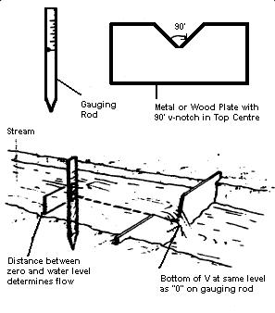
Height of Water  (mm) | Flow (L/s) | Height of Water  (mm) | Flow (L/s)
30 | 0.23 | 115 | 6.24
40 | 0.43 | 120 | 6.93
50 | 0.76 | 125 | 7.67
60 | 1.26 | 130 | 8.46
65 | 1.53 | 135 | 9.29
70 | 1.84 | 140 | 10.2
75 | 2.18 | 145 | 11.1
80 | 2.55 | 150 | 12.1
85 | 2.96 | 155 | 13.1
90 | 3.41 | 160 | 14.2
95 | 3.90 | 165 | 15.3
100 | 4.42 | 170 | 16.5
105 | 4.99 | 175 | 17.7
110 | 5.59 | 180 | 19.0

Method for Measuring Low Streamflow

A simple method for determining the flow of a stream is described in the following steps and illustrated in the figure below. This method should be used when the flow is too low to measure using the v-notch medium flow rate method.

- Channel the streams flow into a small hollow collection basin that is dammed at one end.
- Make sure the basin collects all available water from the stream.
- Place overflow pipe through the dam wall so that water runs freely through it (no leaking).
- Put a bucket of known volume under the pipe.
- Time how long it takes the bucket to fill with water.
- Use the following equation to calculate flow ➔ $\text{Flow}=\frac{\text{Volume}}{\text{Time}}=\frac{L}{s}$

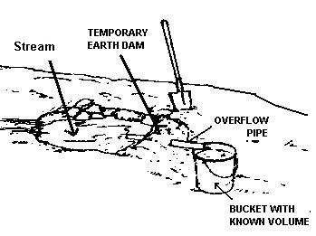

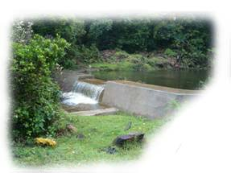
VILLAGE WATER
CONSUMPTION
STREAM
INFLOW
STORAGE
UNIT
EVAPORATION
RESERVOIR
SPILL

