‘RESERVOIR’ HELP FILE

NRWS helps you determine if a reservoir provides adequate conditions for supplying water to a village throughout the year. If you require help developing any of the input variables, click on the respective variable in the list below. To return to this menu, click on any of the arrows at the bottom left corners of the variable descriptions.

- RESERVOIR SURFACE AREA
- GREATEST RESERVOIR DEPTH
- PERCENT RELIABILITY
- RESERVOIR VOLUME
- PERCENTAGE OF RESERVOIR CONSUMED

USER INPUT | DESCRIPTION
RESERVOIR SURFACE AREA | The reservoir surface area should be measured at the end of the dry season when the water level is most likely at its lowest point. Follow the link below to view a simple method for calculating reservoir dimensions.  MEASURING METHOD FOR RESERVOIR DIMENSIONS
GREATEST RESERVOIR DEPTH | The greatest reservoir depth should be measured at the end of the dry season when the water level is most likely at its lowest point. Follow the link below to view a simple method for calculating reservoir dimensions.  MEASURING METHOD FOR RESERVOIR DIMENSIONS
COMPUTER OUTPUT | DESCRIPTION
PERCENT RELIABILITY | Percent reliability of the reservoir system refers to the percentage of days when the actual village water consumption adequately meets the ideal demand due to the presence of water in the storage unit.
RESERVOIR VOLUME | The total reservoir volume is calculated based on the dimensions of the reservoir and the amount of water that is lost to evaporation, transpiration, and seepage.
PERCENTAGE OF RESERVOIR CONSUMED | This variable represents how much water the village uses from the reservoir during a six-month dry period in terms of percentage. A lower percentage of water extracted from the reservoir decreases the impact on the surrounding environment and hydroelectric production. A value of less than 10% is ideal.

Method for Determining Reservoir Volume

A simple method for determining the volume of a reservoir is described in the following steps and illustrated in the figure.

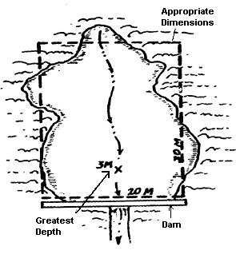
- Lay out an easily measured shape roughly the size of the body of water (ie. triangle, rectangle, circle, or trapezoid).
- Measure dimensions of the shape and then calculate the area.
- Measure the deepest point in the body of water.
  - Take measurements at evenly spaced sections.
  - Use a rope with an anchor or heavy object attached.
  - Throw the anchor into the water keep the rope tight and vertical.
  - Mark where the water level is on the rope.
  - Measure the length from the water level to the anchor.
- The formula in the sample calculation is used for finding the volume.

Sample Calculation
Givens:
- Area: 200m²
- Greatest Depth of Lake: 3m

Calculation:
$\text{Volume}=0\text{.}8∗0\text{.}4∗\text{Depth}∗\text{Area}$= 0.8*0.4*3*200 = 192m³
Note: The percentage of water available after losses due to evaporation, transpiration, and seepage is 80%. As well, assume the average depth of the lake is 0.4 times the greatest depth.

