Re-entrant Arrhythmias in Simulations of the Long-QT Syndrome
RH Clayton, A Bailey, VN Biktashev, AV Holden
University of Leeds, UK

Abstract
In the congenital LQTS, repolarisation of the ventricles is prolonged, and patients with LQTS are at an increased risk of ventricular arrhythmias. Four LQTS phenotypes have been identified. LQT1, LQT2 and LQT4 affect potassium channels, and LQT3 affects sodium channels. The incidence of arrhythmias is higher in LQT1, but the incidence of lethal arrhythmias is higher in LQT3.
The aim of this study was to compare re-entry in simulations of LQT1 and LQT3 myocardium. We modified the Oxsoft equations for the guinea pig ventricular cell to simulate 30 mm x 30 mm 2 dimensional LQT1 and LQT3 preparations. Although there was no difference in vulnerable period between normal, LQT1 and LQT3 simulations, re-entrant wave meander was 3.6 times greater in LQT1 than normal, but only 1.3 times greater in LQT3 than normal. We propose that the greater meander in LQT1 explains the higher incidence of self terminating non-lethal arrhythmias in this phenotype.

1. Introduction
The congenital Long-QT (LQT) syndromes are associated with an increased risk of ventricular arrhythmia [1]. Although abnormalities in sympathetic innervation of the heart were initially considered a candidate mechanism for the LQT syndromes, there is now evidence that specific gene mutations are associated with LQT [2,3]. The phenotypes of three of these mutations have so far been identified, and more will undoubtedly be uncovered. LQT1 is a mutation of the KVLQT1 and/or hminK genes which code for subunits of the channels carrying the slowly inactivating K⁺ current IK_{s}. LQT2 is a mutation of the HERG gene which codes for subunits of channels conveying the rapidly inactivating K⁺ current IK_{r}. LQT3 is a mutation of the SCN5A gene which prevents complete inactivation of Na⁺ channels. In LQT1 and LQT2 repolarisation is prolonged because the outward K⁺ current during the plateau phase of the action potential is reduced. In LQT3, repolarisation is prolonged because there is a persistent inward Na⁺ current throughout the action potential.
Ventricular arrhythmias in the LQT syndromes are often associated with emotional stress, exercise, or a lowered heart rate, and these features suggest initiation by afterdepolarisations [1,3]. Many LQT arrhythmias show the characteristic waxing and waning the in the ECG that is classified as torsade de pointes by cardiologists, these is evidence that once initiated these arrhythmias are sustained by re-entrant waves [4]. Self termination of torsade de pointes is well documented [5]
The behaviour of functional re-entrant waves has been studied in both mammalian hearts and computational models of myocardium. These studies have shown that re-entrant waves do not rotate rigidly. Instead, the tip of a re-entrant wave rotates around a core that is mobile. In homogenous isotropic and anisotropic media the core meanders with a characteristic pattern that depends on local electrophysiology. In heterogenous media meander is accompanied by drift. If the core of the re-entrant wave moves beyond the inexcitable boundary of the medium then re-entry ceases, and this has been proposed as a mechanism for self termination of arrhythmias [6].
A recent study in a limited group of patients has shown that although the incidence of ventricular arrhythmias in patients with LQT1, the incidence of lethal arrhythmias is five times greater in LQT3 than in LQT1 [7]. This finding suggests that arrhythmias in patients with LQT1 are more likely to self terminate than arrhythmias in patients with LQT3. The aim of the present study was therefore to compare the characteristics of re-entrant arrhythmias in simulations of LQT1 and LQT3.
2. Methods
We simulated action potential propagation in continuous and isotropic 1 and 2 dimensional excitable media. We used the Oxsoft equations for the guinea pig ventricular cell to describe membrane excitability, incorporating the equations for the IK_{s} and IK_{r} currents described in the most recent version of the model [8]. For normal tissue, we scaled the maximal conductances GK_{s}, GK_{r1} and GK_{r2} so that the total IK_{s} + IK_{r} during repolarisation was equal to the total IK during repolarisation in the older model, while keeping the ratio of GK_{s} to GK_{r} constant. This model of normal ventricular myocardium had an action potential duration of 153 ms and a propagation speed of 0.6 ms⁻¹ for plane waves.
We simulated LQT1 by progressively reducing GK_{s} from a normal value of 0.007 μS to 0.0032, 0.0016, 0.0008, 0.0004, and 0.0002 μS. We simulated LQT3 by preventing a fraction gB of Na channels from inactivating. We progressively increased gB from 0.0000 for normal tissue to 0.0001, 0.0002, 0.0004, 0.0008, and 0.0016. Figures 1 and 2 show normal and prolonged action potentials for the LQT1 and LQT3 simulations.
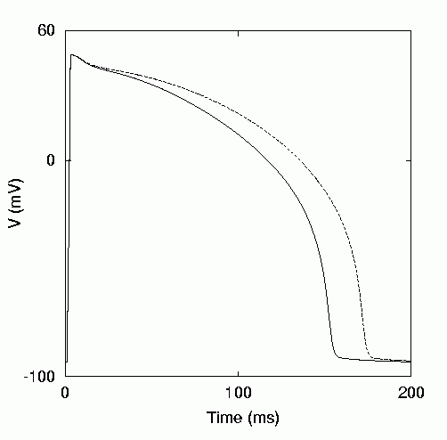
Figure 1: Action potentials of simulated normal and LQT1 (GK_{s}= 0.0002 μS) tissue.
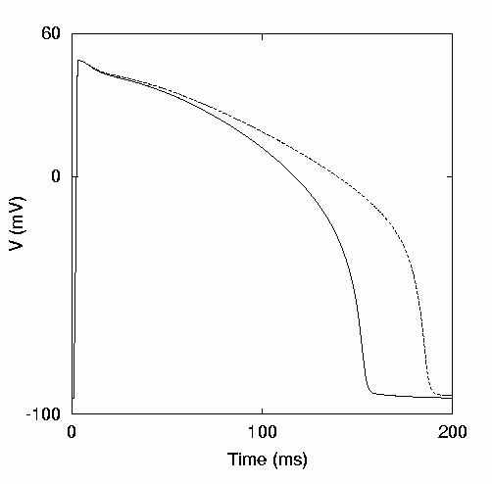
Figure 2: Action potentials of simulated normal and LQT3 (gB = 0.0016) tissue.

We measured the vulnerable period for simulated normal and LQT tissue in a 1 dimensional cable 10 mm long. A single extrastimulus was delivered in the wake of a plane wave and the time of delivery increased in steps of 1 ms. The vulnerable period was defined as the range of extrastimulus times that elicited unidirectional propagation as described previously [9].
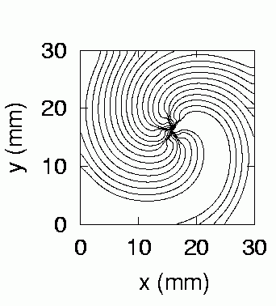
Figure 3: Re-entry in normal myocardium; voltage isochrones at 5 ms intervals between 1.00 and 1.12 s after initiation of re-entry.

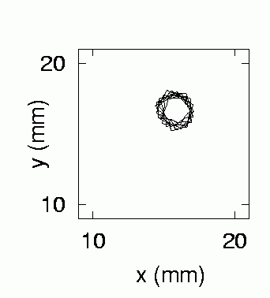
Figure 4: Meander of the re-entrant core in simulated normal tissue between 1 and 2 after initiation of re-entry.

We studied re-entry in a 2 dimensional medium representing a 30 x 30 mm square of myocardium. The 2 dimensional cable equation describing action potential propagation was solved numerically using the scheme described elsewhere [9], with a space step corresponding to 100 um, a time step corresponding to 50 us, and a diffusion constant of 31.25 mm²s⁻¹. Re-entry was initiated using the phase distribution method [9], and the position of the re-entrant core was determined from the intersection of isolines of voltage and Ca channel inactivation. Figure 3 shows re-entry in normal tissue and Figure 4 the trajectory of the re-entrant core.
3. Results
The width of the vulnerable period for simulated normal tissue was 6 ms, and was unchanged for both the LQT1 and LQT2 simulations.
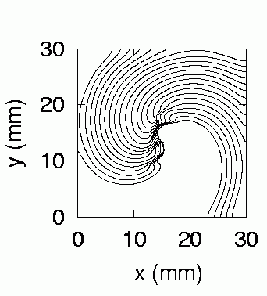
Figure 5: Re-entry in LQT1 myocardium with GK_{s} 0.0002 μS; voltage isochrones at 5 ms intervals between 1.00 and 1.12 s after initiation of re-entry.

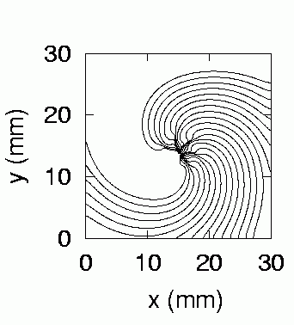

Figure 6: Re-entry in LQT3 myocardium with gB 0.0016; voltage isochrones at 5 ms intervals between 1.00 and 1.12 s after initiation of re-entry.

Isochrones and the patterns of meander for re-entrant waves in LQT1 and LQT3 are shown in Figures 5-8. The extent of meander in simulated LQT1 tissue was much greater than the extent of meander in LQT3 tissue. Furthermore, meander in simulated LQT1 increased with time, and in the simulation with lowest GK_{s} the meander was great enough for re-entry to become extinguished.
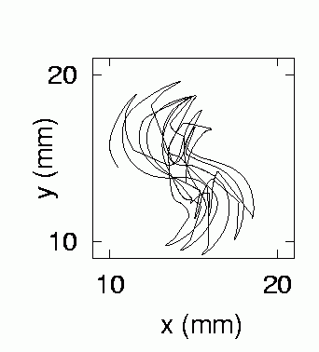
Figure 7: Meander of the re-entrant core in simulated LQT1 tissue between 1 and 2 after initiation of re-entry.
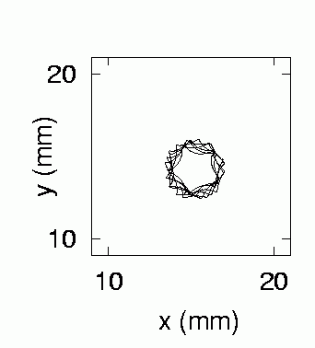
Figure 8: Meander of the re-entrant core in simulated LQT3 tissue between 1 and 2 after initiation of re-entry.

We quantified the extent of meander by the radius of the circle enclosing the entire meander trajectory. Between initiation and 1 s, the extent of meander for the LQT1 simulation with the longest action potential duration (GK_{s}=0.0002μS) was 3.3 mm, compared to 1.9 mm for simulated normal tissue and 2.3 mm for simulated LQT3 tissue with the longest action potential duration (gB=0.0016). For the period between 1 and 2 s after initiation these figures were 4.7 mm, 1.3 mm, and 1.8 mm respectively.

4. Discussion
This study has shown that small changes to ionic currents at the cellular level arising from gene mutations can have a dramatic influence on the larger scale behaviour of myocardium.
There are several limitations to this study. First, we have neglected the initiation of re-entry. It seems that afterdepolarisations are the most likely mechanism of initiation in the LQTS [4]. Second, the computations in this study have been restricted to two dimensions. Re-entry in the ventricles is a three dimensional phenomenon, and the third dimension may be important for the stability of the re-entrant wave [10]. It is possible that re-entrant waves are less stable in LQT3, and that this is an important factor in the higher incidence of lethal arrhythmias in patients with this genotype. Third, we have not taken into account the regional distribution of mutant ion channels within the ventricle. There is only limited information at present [3].
Despite these limitations this study has shown that it is possible to do computational experiments that simulate the functional, organ-wide consequences of gene mutations in physiological systems. As our knowledge of the detailed molecular mechanisms that underpin life itself increases, so our need to integrate this information grows. There is so much information available that computation offers the only realistic way to make use of it.

5. Conclusions
In this study we have shown that small changes in the behaviour of cardiac cells can affect tissue behaviour. In simulations of LQT1 and LQT3, we have shown that the width of the vulnerable window is no different to normal tissue, but the meander of re-entrant waves is dramatically increased in LQT1 and modestly increased in LQT3. We propose that meander beyond the excitable boundary of the ventricles is the mechanism by which some ventricular arrhythmias self-terminate, and that the greater meander of re-entrant waves in LQT1 compared to LQT3 explains the higher incidence of self-terminating arrhythmias in patients with LQT1.

Acknowledgements

This work has been supported by the British Heart Foundation through the award of a Basic Science Lectureship to RHC, and by grants from the Wellcome Trust and EPSRC..
References
[1] Schwartz PJ, Locati EH, Napolitano C, and Priori SG. The Long QT syndrome. In: Cardiac Electrophysiology from Cell to Bedside (2nd Edition). Philadelphia: WB Saunders, 1995:788-811.
[2] Ackermann MJ, Clapham DE. Ion channels – Basic science and clinical disease. New Engl J Med 1997;336:1575-86.
[3] Priori SG, et al. Genetic and molecular basis of cardiac arrhythmias: Impact on clinical management Circulation 1999;99:518-528
[4] El-Sherif N, Caref EB, Yin H, Restivo M. The electrophysiological mechanism of ventricular arrhythmias in the long QT syndrome. Tridimensional analysis of activation and recovery patterns. Circulation 1996;79:474-92.
[5] Haverkamp W, Shenasa M, Borggrefe M, Breithardt G. Torsade de pointes. In: Cardiac Electrophysiology from Cell to Bedside (2nd Edition). Philadelphia: WB Saunders, 1995:885-99.
[6] Davidenko JM, Pertsov AM, Salamonsz R, Baxter W, Jalife J. Stationary and drifting spiral waves of excitation in isolated cardiac tissue. Nature 1992;335:349-51.
[7] Zareba W, and others. Influence of the genotype on the clinical course of the long-QT syndrome. New Engl J Med 1998;339:960-65.
[8] Biktashev VN, Holden AV. Re-entrant waves and their elimination in a model of mammalian ventricular tissue. Chaos 1998;8:48-56.
[9] Noble D, Varghese A, Kohl P, Noble P. Improved guinea pig ventricular cell model incorporating a diadic space, IKr and IKs, and length and tension dependent processes. Can J Cardiol 1998;14:123-34.
[10] Winfree AT. Rotors, fibrillation and dimensionality. In: Computational Biology of the Heart. AV Holden AV Panfilov Eds. John Wiley. New York 1997:101-36.

Address for correspondence.

Richard H Clayton,
School of Biomedical Sciences, University of Leeds, Woodhouse Lane, Leeds LS2 9JT

E-mail richard@cbiol.leeds.ac.uk

